MUGSHOTS!

Monday, August 11, 2014

my sister and me half went shoping on black friday

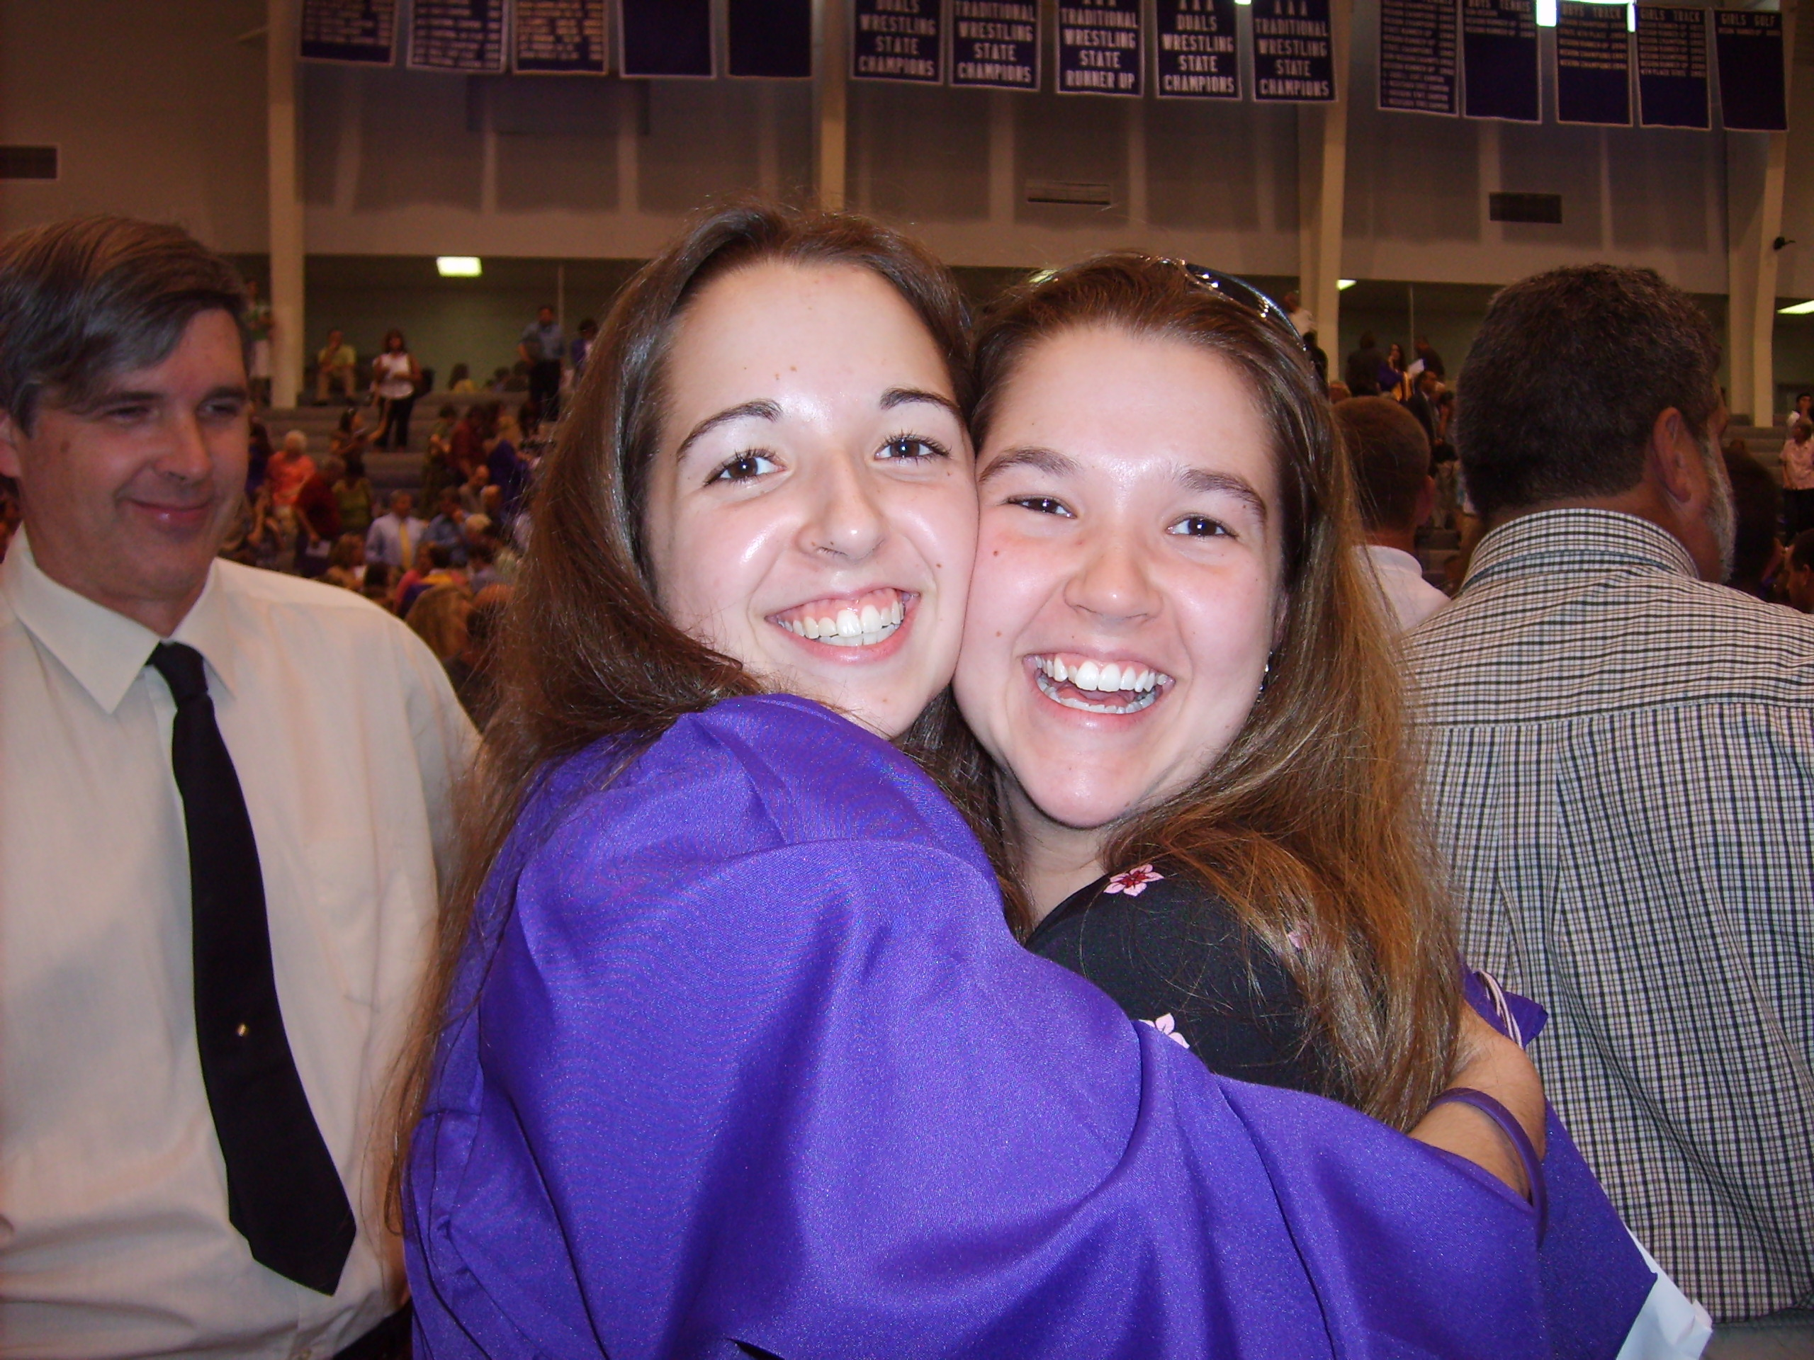

my cat holla kilt a rabitt in the feild and my other cat eight it



