MUGSHOTS
did u no that were north of gilmer county

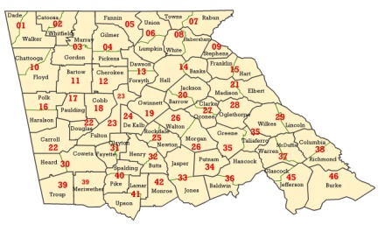
austin brung him a blankit too my hous
